
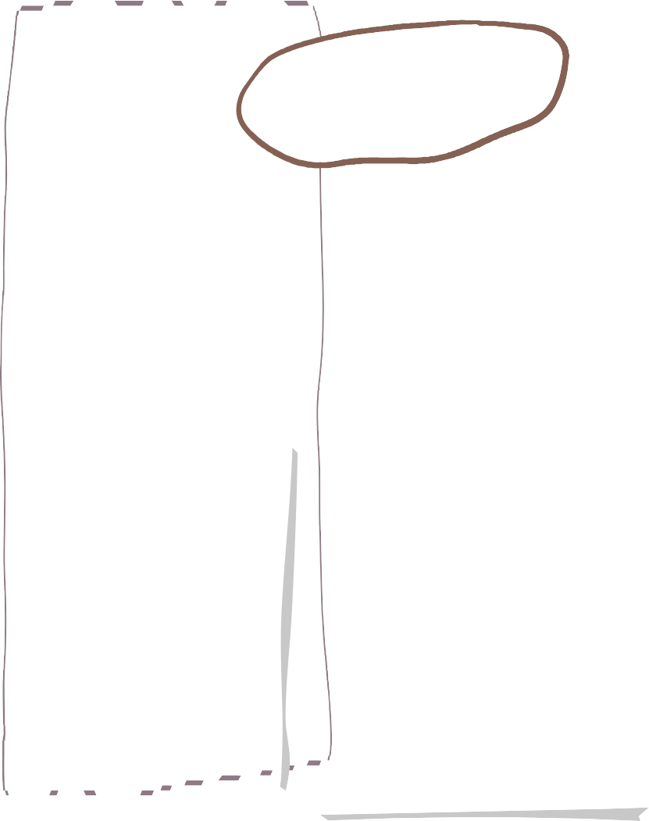




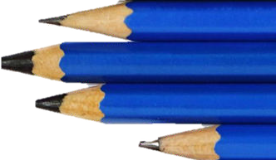

Summer term in Class 4

This half term we will continue with the ‘Read, Write, Inc” programme to develop our spelling skills. Each week we will learn a new spelling rule.
We will continue to use the “SfA” programme for guided reading, ensuring children are immersed in a range of high-quality texts that they can unpick and explore.
In writing, we will be focusing on narratives and with a flashback. We will be describing characters and settings and integrating dialogue between characters.
History

English
Maths

We are reading…
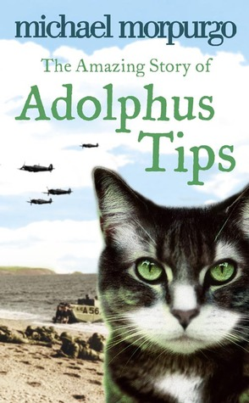
Books and stories that we will focus on this term are

Our History challenge question is:
How did Winston Churchill lead Britain through war?
During this unit of work we will explore the key events of WW2, which countries were the allies and axis and how it affected Britain. We will look deeper into evacuation, the Blitz and rationing. We will discover how women were important in WW2 and we will understand how propaganda was used during this time.
We follow the White Rose Maths Scheme. This term, children will explore …

Year 5 – Perimeter, area and volume
- Decimals, fractions, percentages
- Shape

Year 6 – SAT practice
- Algebra and ratio
- Shape and measure


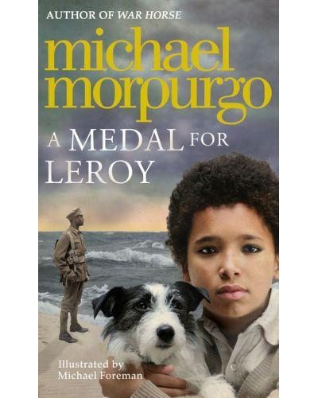

Your child will continue to bring their reading book home this term. It will come home every day and should be returned on a daily basis. Please support your child’s reading development by reading for 5 minutes every day. Children can earn dojo points for each signature in their reading diary. This can also lead to exciting prizes.
Homework will be given out on a Thursday and should be returned by the following Wednesday. Please support your child in completing one homework choice from the grid and their weekly task which is based upon school work from that week.
Spellings will be given out on a Monday and should be returned no later than Thursday, in time for their spelling test on Friday.

General Info

Art and Design
Science
PE

In PE, during summer 1, we have a golf coach who will be teaching the children and focusing on accuracy and control when hitting the ball. In summer 2, we will learn how to throw, jump and run with precision, speed and power within our athletics topic.
Our challenge question in Science this term is…
How are living things grouped and classified?
We will group organisms depending on their features and build upon our previous knowledge of their characteristics.
We will learn how to group plants and learn about a scientist called Carl Linneaus. We will investigate micro-organisms and learn about how and where they grow. We will then use our observation skills to discover which types of living things are in our area.
Our Challenge question in Art and Design will be:

Why is working with oil paint or acrylic paint so different?

We will learn about the quick drying of the acrylic paint and its ability to blend easily and compare this to the slow drying of the oil paint making it easier to layer.
We will test both types
of paint and improve our
skills and technique.



Computing

- 11th-14th May – KS2 SATs Week.
- Friday 15th May – Edinburgh residential meeting.
- 19th May – Year 6 – Planet Leisure Trip.
- 3rd-5th June – Edinburgh Trip
- 9Th June – colour run (in school event)
- 23rd June – Alternate sports event (Class 4)
- 30th June – Year 6 Ferryhill School Transition.

Diary Dates
Our Purple Mash learning this term will be:
- Networks
- Quizzing

Children will use our laptops in class to access their learning in Maths through Freckle and TTrockstars.
TTrockstars can be accessed at home by using the child’s username and password.



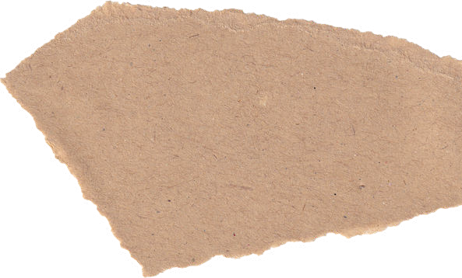


Women Artists

We will be exploring how different parts of the song can be sung by different people with different tones. We will begin to recognize different styles of music and we will start to share and perform our own songs. 

Music

