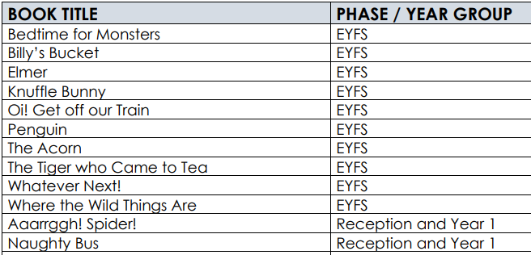

Cycle A and B Comprehension Texts Timetable

|  |  |  |  |  |  |  |
| --- | --- | --- | --- | --- | --- | --- |
|  | **Autumn 1** | **Autumn 2** | **Spring 1** | **Spring 2** | **Summer 1** | **Summer 2** |
| **Cycle A** |  |  |  |  |  |  |
|
| **Cycle B** |  |  |  |  |  |  |